**2 1CY681– Internet Protocol lab**

**Name: Akhil K J**

**Register Number : CYS22009**

**Title: Understanding BGP using Cisco Packet Tracer**

**Date of Assignment provided: 17/11/2022**

**Aim: To study about BGP Routing using Cisco Packet Tracer**

Architecture

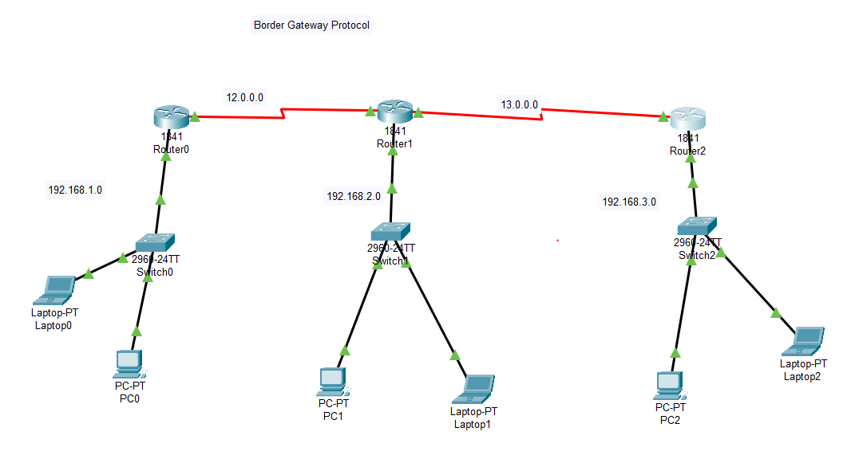

Router 1

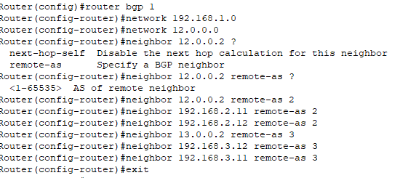

Router 2

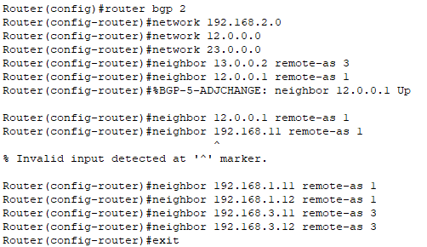

Router 3

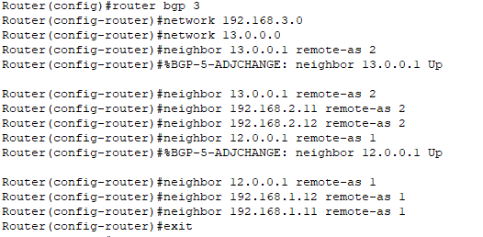

Result

